Goals for School Visit: build insights about middle school classroom dynamics, especially for teacher-student relationships.

[Demographics for school](http://profiles.doe.mass.edu/accountability/report/school.aspx?linkid=31&orgcode=00490310&):

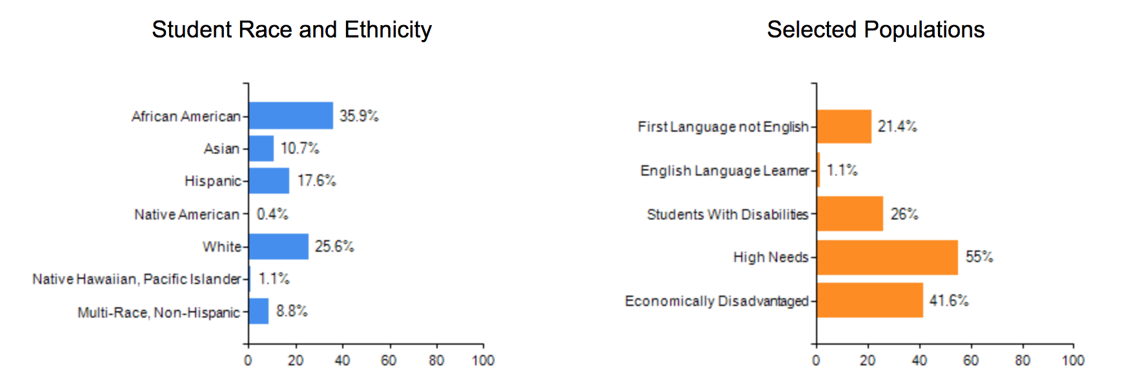

Talk to teachers:

* Join for a 30 min session to observe interactions and class
* Get contact information for follow-up conversations

Talk to students:

* After school, ask questions as they exit the class
* Ask questions during dismissal (lockers, waiting etc.)

**TEACHERS:**

1. Are you comfortable answering questions? What is your name? What year and subject do you teach?
2. What are the biggest challenges you face in your job?
3. Why did you decide to be a teacher?
4. What’s the favorite part of your job?
5. When do you feel like you are most effective as a teacher? What encourages this aspect of your teaching? And what obstructs this aspect of your teaching?
6. What are the barriers to forming relationships with students?
7. How did you develop the strongest relationship with students? What are specific tactics that you would recommend to new teachers?
8. How many of your students do you feel like you have a real connection/know as well as you would like to? Do you feel like there is a disconnect between teachers and students?
9. What are some scenarios where you think there is opportunity to build relationships with your students?
10. Do you think relationship between students and teacher affect student academic outcomes?

**STUDENTS:**

1. What is your name? What grade are you in?
2. What do you like/dislike about school?
3. What is your favorite thing about your teacher? OR Who’s your favorite teacher? Why?
4. What’s your favorite subject in school? What do you like about that subject?
5. Do you feel respected by your teacher? What makes you feel this way? OR Do you feel respected in the classroom? What makes you feel this way?
6. Have you raised your hand in class this week? Which classes do you raise your hand in more? Why?
7. If you do not understand something, what do you do?
8. In class, do you ever talk about your life outside of class with your teacher?
9. Do you engage with your teacher outside of class? How? (i.e. during lunch time, early in the morning, quick chat after school?)
10. Do you feel like you have a personal relationship with your teacher? What makes you feel this way?